**ARCHITECTURE DIAGRAM**

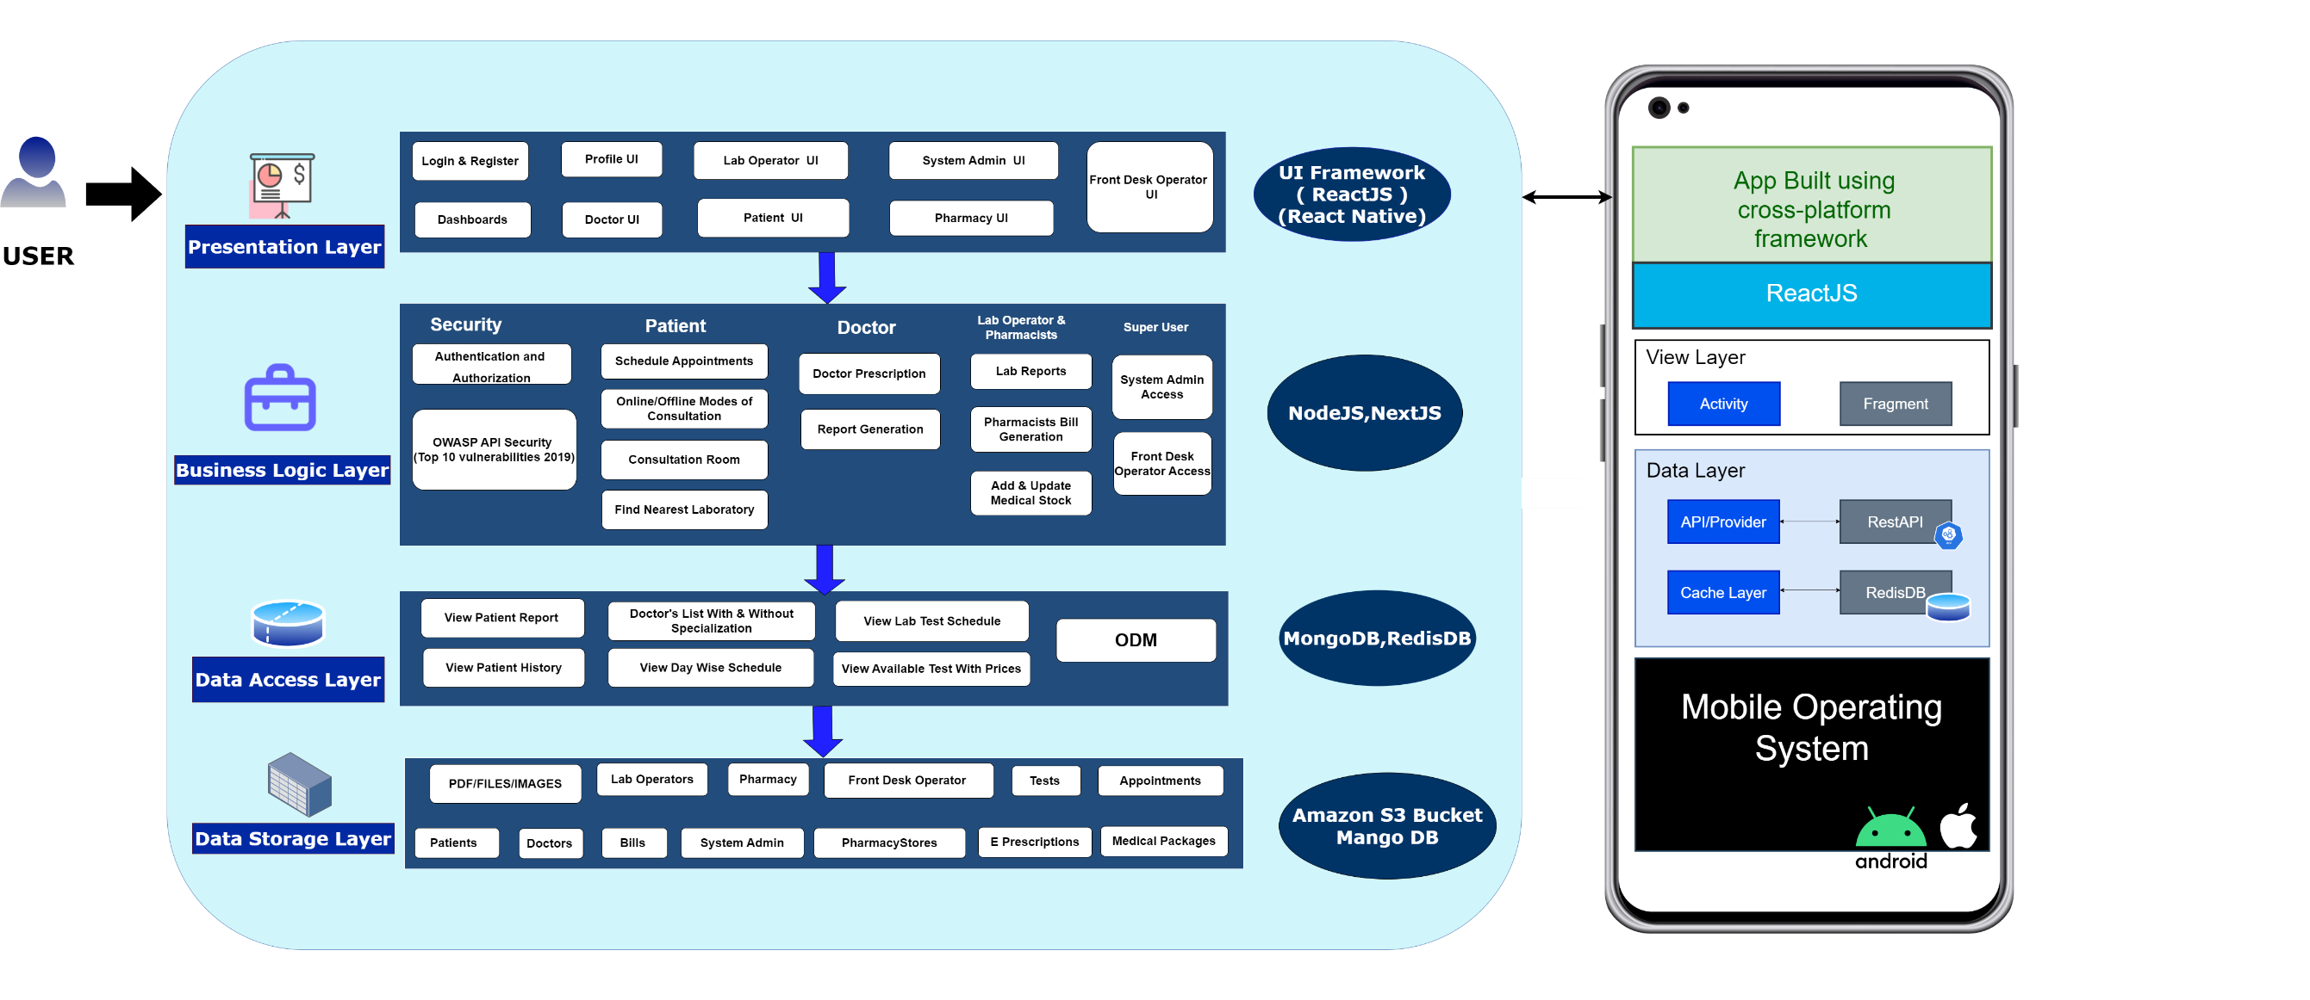

**To view this architecture diagram in web click or copy paste the link below**

[**https://viewer.diagrams.net/?tags=%7B%7D&highlight=0000ff&edit=_blank&layers=1&nav=1&title=architure%20diagram.drawio#Uhttps%3A%2F%2Fdrive.google.com%2Fuc%3Fid%3D1JFGRK9juEeU_TAyVzk1-8DkHFtein3Y_%26export%3Ddownload**](https://viewer.diagrams.net/?tags=%7B%7D&highlight=0000ff&edit=_blank&layers=1&nav=1&title=architure%20diagram.drawio#Uhttps%3A%2F%2Fdrive.google.com%2Fuc%3Fid%3D1JFGRK9juEeU_TAyVzk1-8DkHFtein3Y_%26export%3Ddownload)

**DATABASE DESIGN DIAGRAM**

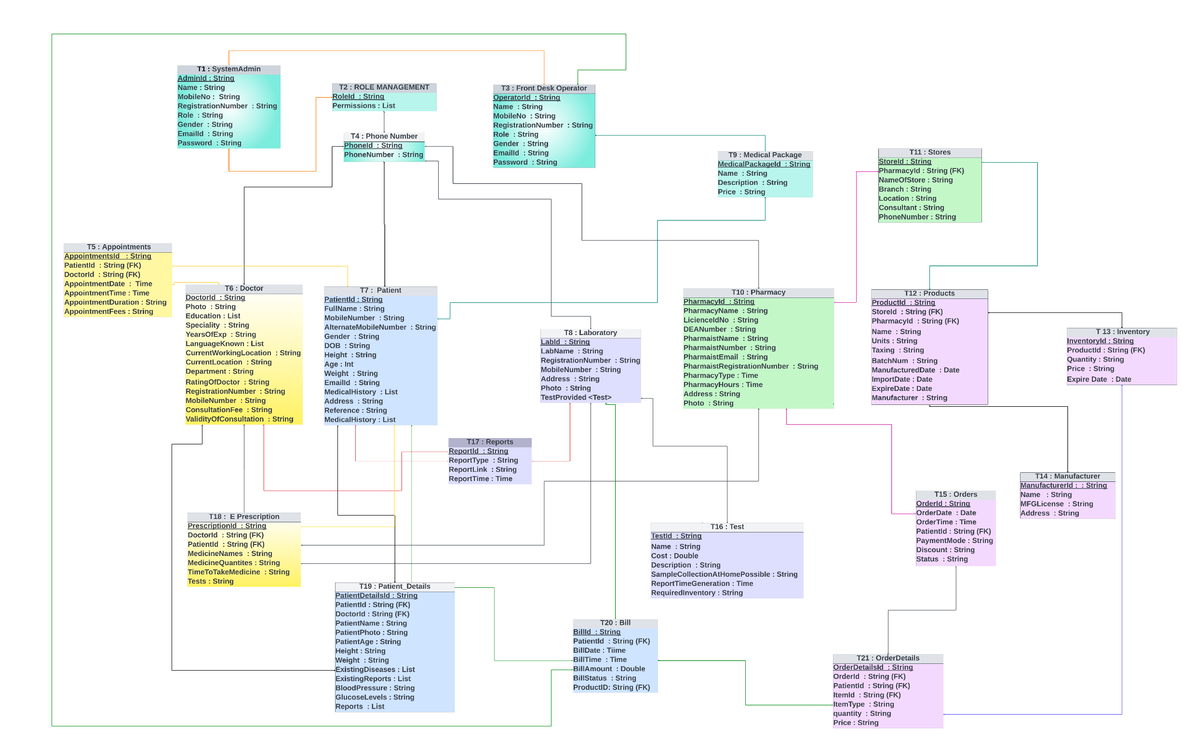

T1 : **SystemAdmin** **:** AdminId (PK) ,Name , MobileNo , RegistrationNumber , Role , Gender , EmailId, Password  **:** This is the super user in the proposed system. Admin will have access to all the Modules

T2 : **ROLE MANAGEMENT** : RoleId (PK), Permissions : This table is used for permissions

T3 : **Front Desk Operator** : OperatorId (PK), Name , MobileNo , RegistrationNumber , Role , Gender, EmailId , Password : Bills and payments can also be accessed by the Front desk operator. The front desk operator will have access to all and medical packages and discounts will be managed by front desk operator .

T4 : **Phone Number** : PhoneId (PK), PhoneNumber : It will store all the phone numbers.and with accordinly give access to the particular user

T5 : **Appointments :** AppointmentsId (PK), PatientId (FK), DoctorId (FK) ,AppointmentDate, AppointmentTime , AppointmentDuration , AppointmentFees **:** The appointemnts booking will be stored in this table with reference to the patinetsid and doctorsID .

T6 : **Doctor :** DoctorId (PK), Photo , Education ,Speciality , YearsOfExp ,LanguageKnown, CurrentWorkingLocation ,CurrentLocation , Department ,RatingOfDoctor RegistrationNumber , MobileNumber ,ConsultationFee ,ValidityOfConsultation : The individual doctor details will be stored here and Doctorid is the Foreign key. It has a relationship with E Precription table.

T7 : **Patient :** PatientId , FullName , MobileNumber , AlternateMobileNumber , Gender , DOB , Height , Age : Int Weight , EmailId , MedicalHistory , Address , Reference , MedicalHistory ,

T8 : **Laboratory :** LabId , LabName , RegistrationNumber , MobileNumber , Address , Photo , TestProvided <TEST > : Apart from laboratory details, this table is connected to Test table

T9 : **Medical Package :** MedicalPackageId , Name , Description , Price , : The medical packages which are dialy updated by the front desk operator will be stored in this and will be accessed by the patients and they can use the packages .

T10 : **Pharmacy :** PharmacyId , PharmacyName , LicienceIdNo , DEANumber , PharmaistName , PharmaistNumber , PharmaistEmail , PharmaistRegistrationNumber , PharmacyType PharmacyHours ,Address , Photo : Maintains pharmacy operations. It has connections to the Store table.

T11 : **Stores :** StoreId , PharmacyId , (FK) NameOfStore , Branch , Location , Consultant , PhoneNumber : The stores contains all the stores which are registred under the pharmacy table. The store table is connected to the products table

T12 : **Products :** ProductId , StoreId , (FK) PharmacyId , (FK) Name , Units , Taxing , BatchNum , ManufacturedDate , ImportDate , ExpireDate , Manufacturer : Contains all the Products like medicines etc., available in the stores. This table has relationship with inventory table.

T13 : **Inventory :** InventoryId , ProductId , (FK) Quantity , Price , Expire Date : Comprises all medicines details. Like how many tables from a company and its details . This has relationship with ordered details table.

T14 : **Manufacturer :** ManufacturerId : , Name , MFGLicense , Address : The manufacturer details of the medicines will be stored In this .

T15 : **Orders :** OrderId , OrderDate , OrderTime ,PatientId , (FK) PaymentMode , Discount , Status , : Ther orders which are received from the patient will be stored in this .

T16 : **Test :** TestId , Patient ID , (FK) Name , Cost : Double Description , SampleCollectionAtHomePossible , ReportTimeGeneration ,RequiredInventory : The test table will contain all the tests provided by the laboratory.

T17 : **Reports :** ReportId ,ReportType ,ReportLink,ReportTime : will be accessed by Doctors, lab operator, patient

T18 : **E Prescription :** PrescriptionId (PK), DoctorId (FK) ,PatientId (FK), MedicineNames MedicineQuantites , TimeToTakeMedicine , Tests : Contains the prescription given by the doctors which will be accessible by the Patient, Pharmacy and Lab operator.

T19 : **Patient_Details :** PatientDetailsId ,PatientId (FK), DoctorId (FK), PatientName , PatientPhoto , PatientAge , Height , Weight , ExistingDiseases, ExistingReports , BloodPressure , GlucoseLevels ,Reports : It has relationship with Doctor Table. By this the doctor can view the health conditions of the patients before consultation.

T20 : **Bill :** BillId (PK), PatientId (FK), BillDate ,BillTime , BillAmount , BillStatus , ProductID, (FK) : Contains all the billing information. The bills belong to patient, pharmacy, laboratory and consultation Fees. It is connected to front desk operator table.

T21 : **OrderDetails :** OrderDetailsId (PK), OrderId (FK) ,PatientId (FK), ItemId (FK) ,ItemType , quantity,Price : This contains all the orders received from the patient.

**Patient Module :** Registration, Online consultation, Follow-up consultation, Schedule lab test, Previous consultations, Profile management

**Doctor Module :** Registration, Today’s consultations, Previous consultations, Calendar, View Scheduled Appointments ,Receive Notifications, View lab reports, Prescribe lab tests, Prepare Prescription

**Pharmacy Module :** Generate invoice, Payments, Stock availability etc.

**Lab operator Module** : Today’s appointments, Previous appointments, Upload reports

**System Admin Module :** Access to all the Modules

**Front desk Operator Module** : Controlled by system admin and access accordingly, Managing other information like payments, medical packages, discounts